复旦大学国际文化交流学院2020年春季汉语课程

告知书

**Guidebook for Taking Chinese Courses in 2020 Spring Semester of International Cultural Exchange School, Fudan University**

各位同学好！

复旦大学国际文化交流学院2020年春季汉语网络课程，3月2日正式开始。请同学们注意如下信息：

Dear students,

As the new semester is coming, our online Chinese courses will officially start on 2nd, March. Here we sort and summarize a guidebook to help you better understand the methods and rules of taking online courses. Please pay attention to the following information.

**1.网络汉语课程的链接：**

1. **Links to online Chinese courses**

A 拾级汉语第1级 Chinese Level 1：

https://mooc1-1.chaoxing.com/course/209637806.html

B 拾级汉语第2级 Chinese Level 2：

<https://mooc1-1.chaoxing.com/course/208791482.html>

C 拾级汉语第3级 Chinese Level 3：

<https://mooc1-1.chaoxing.com/course/208279618.html>

D 拾级汉语第4级 Chinese Level 4：

<https://mooc1.chaoxing.com/course/209528178.html>

E 拾级汉语第5级 Chinese Level 5：

<https://mooc1.chaoxing.com/course/209536058.html>

F 拾级汉语第6级 Chinese Level 6：

<https://mooc1.chaoxing.com/course/209539176.html>

G 拾级汉语第7级 Chinese Level 7：

<https://mooc1-1.chaoxing.com/course/209171813.html>

H 拾级汉语第8级 Chinese Level 8：

<https://mooc1-1.chaoxing.com/course/208523439.html>

I 拾级汉语第9级 Chinese Level 9：

<https://mooc1-1.chaoxing.com/course/208259504.html>

**2.登录方式：**

1. **Log in**

第1步：已报名的学生都已被分入相应班级，分班名单参见附件1，请查阅附件确定自己的班级。

Step 1: All registered students have been assigned to corresponding classes, please see the attachment 1 to check your class.

第2步；点开对应的课程链接。例如，如果你是C1班，请你打开“C 拾级汉语第3级”的课程链接，进入下面的网页：

Step 2: Open the corresponding course link. For example, if you are in class C1, please open the link of “Chinese-Level 3” and you will see the page as follows:

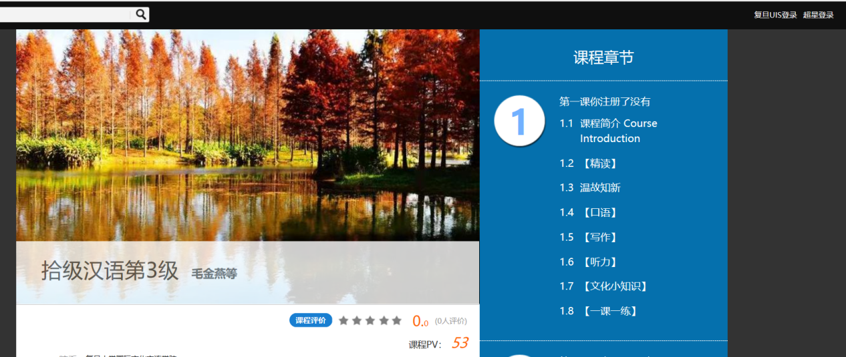

第3步：点击右上角的“超星登录”，进入课程的登录页面：

Step 3: Click "超星登陆" in the upper right corner to enter the course login page.

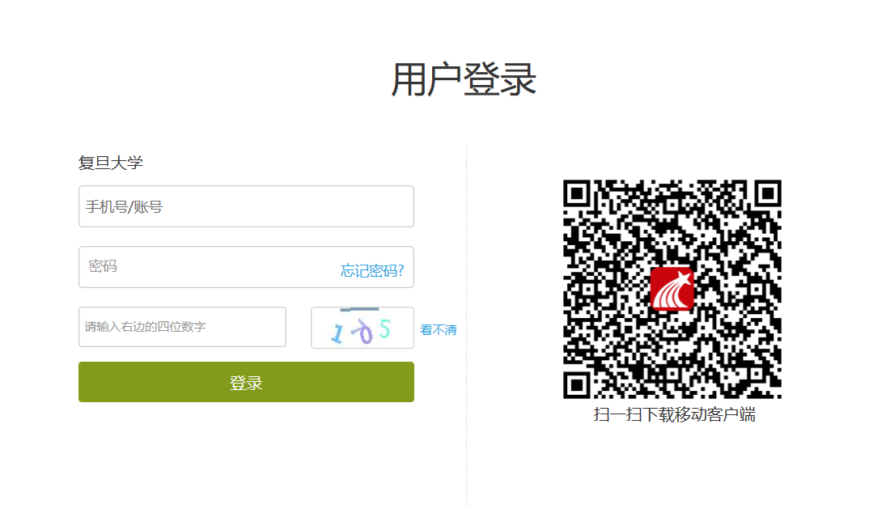

老生：“手机号/账号（USERNAME）”是你的学号，如果你没有修改过密码，初始“密码（PASSWORD）”是123456。

Old students："手机号/账号（USERNAME）" is your student number. If you haven't changed your password, the initial “密码（PASSWORD）” is 123456.

新生：“手机号/账号（USERNAME）”是你的申请编号，初始“密码PASSWORD）”是123456。

New students："手机号/账号（USERNAME）" is your application number, and the initial "密码（PASSWORD）" is 123456.

第4步：加入班级微信群。进入课程以后，点击“我学的课”，然后点击“通知”，在这里你们可以找到班级群的微信账号或者微信群二维码。**请注意**：每个学生只有加入班级群，才能参加师生互动。

Step 4: Join the class wechat group. After entering the course, click "我学的课(my lessons)" and then click "通知(notice)". Here you can find the wechat account or wechat group QR code of the class. Please note: each student can only participate in the interaction between teachers and students by joining the class group.

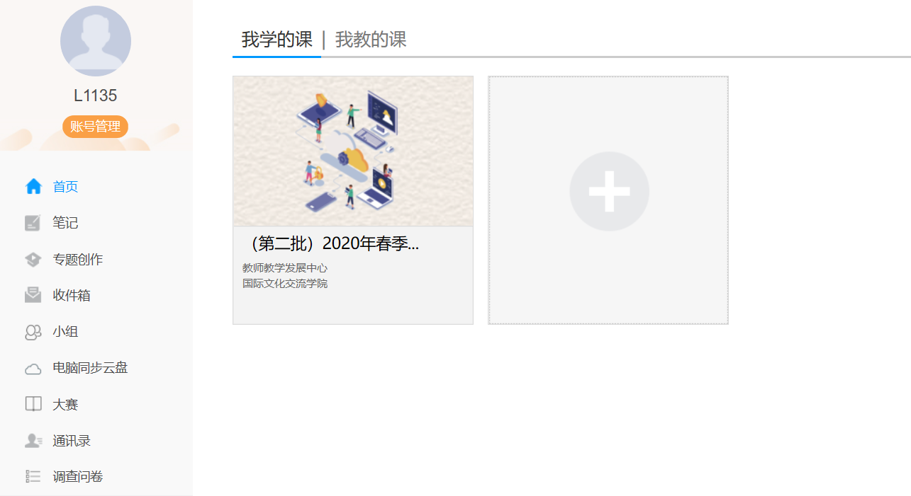

**\*点击“通知”可以找到班级群的微信二维码。**

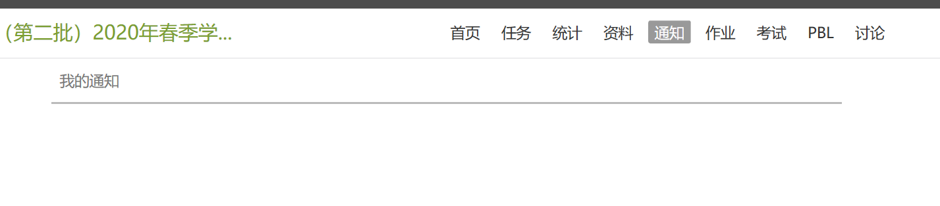

**3.相关等级汉语课程表和分班名单：见附件1和附件2。**

**Schedule of Chinese courses and lists of classes: See Attachment 1 and Attachment 2.**

**附件1：分班名单**

如果您在分班名单中没有找到您的名字，请发邮件至jiaowuke@fudan.edu.cn，邮件中注明护照姓名、申请编号或学号。

**Attachment 1: Class List**

If you didn’t find your name in the class lists, please send an email to jiaowuke@fudan.edu.cn, providing your passport name, application number or student number.

**附件2：课程表**

**请注意，课程表中的时间均为北京时间。**

**Attachment 2: Class Schedule**

Please note that all the time in this schedule is Beijing time.

国际文化交流学院

International Cultural Exchange School,

Fudan University

2020年2月29日February 29, 2020